Flask and MongoDB assignments

- Create a Flask application with an /api route. When this route is accessed, it should return a JSON list. The data should be stored in a backend file, read from it, and sent as a response

Code :

from flask import Flask, jsonify
import json

app = Flask(__name__)

@app.route('/')
def home():
return '''
<html>
<head><title>Flask API Server</title></head>
<body>
<h1>Flask API Server</h1>
<p>API Endpoint: <a href="/api">/api</a></p>
<p>This endpoint returns JSON data stored in a backend file.</p>
</body>
</html>
'''

@app.route('/api')
def api():
file = open(r'C:\Users\adesh\Python_Tutesdude\Microservice\data.json', 'r')
data = json.load(file)
file.close()
return jsonify(data)

if __name__ == '__main__':
app.run(debug=True)

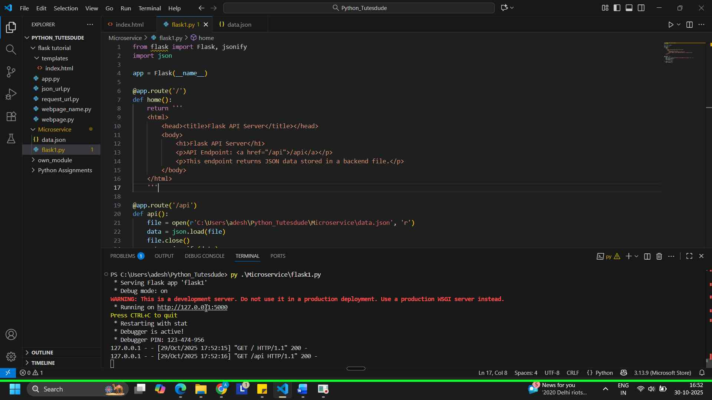

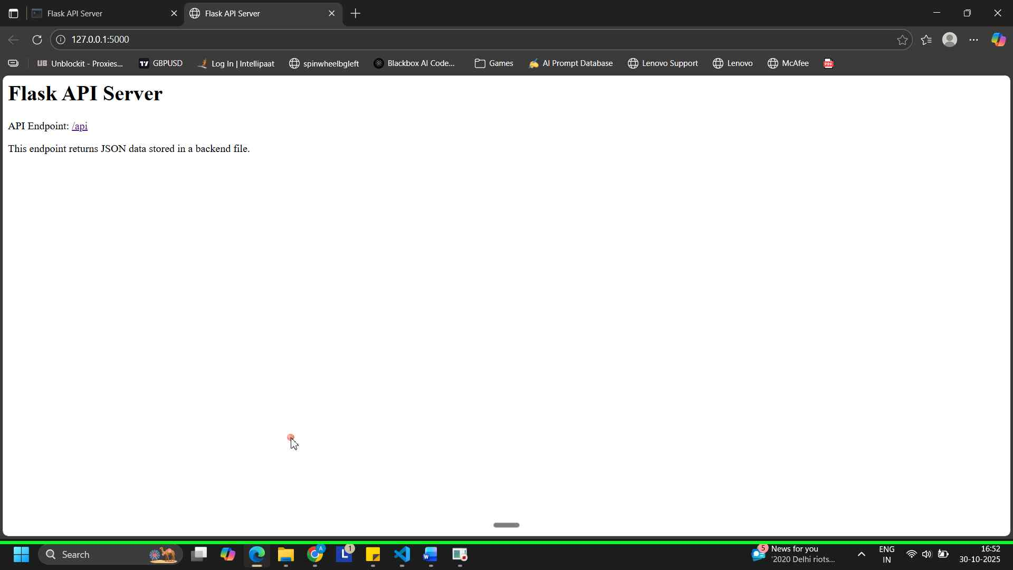
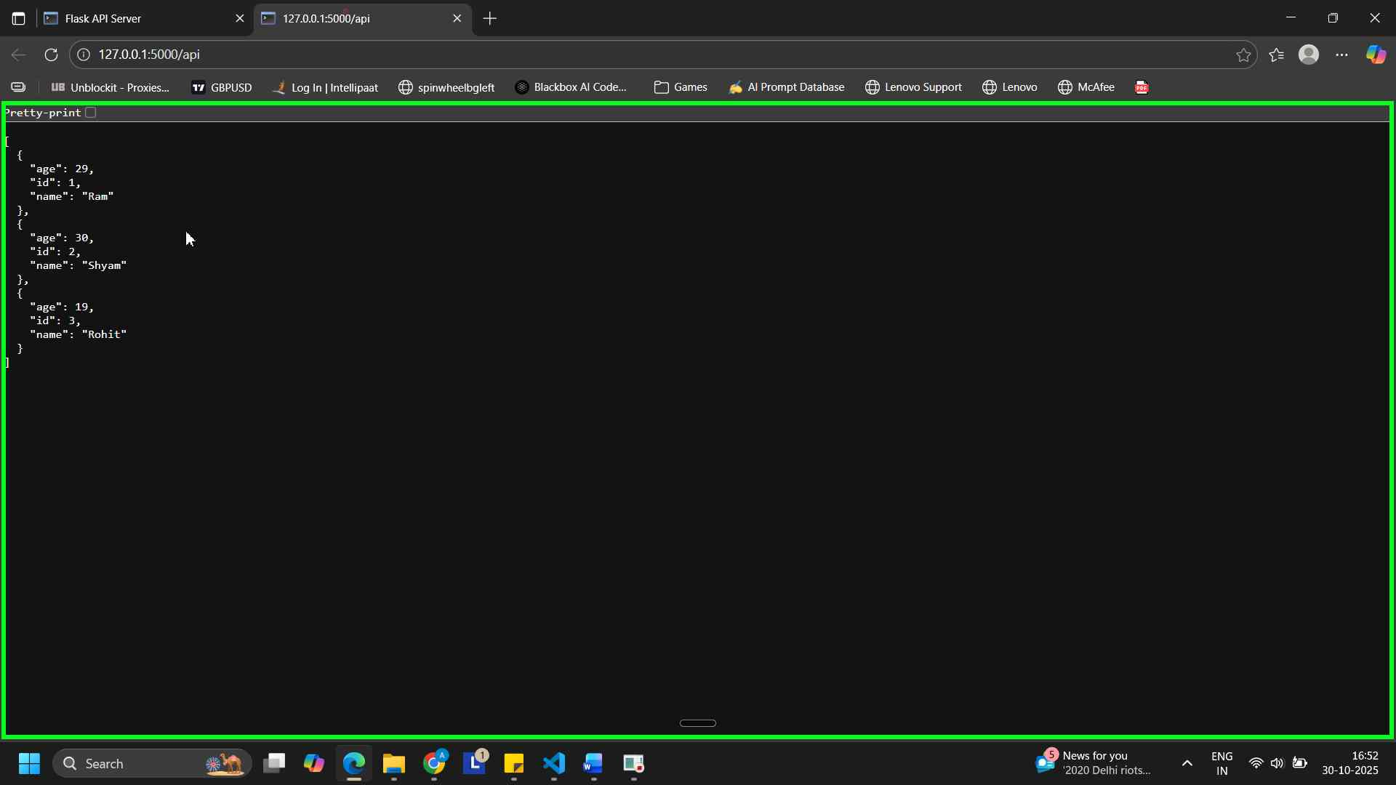

- Create a form on the frontend that, when submitted, inserts data into MongoDB Atlas. Upon successful submission, the user should be redirected to another page displaying the message "Data submitted successfully". If there's an error during submission, display the error on the same page without redirection.

Code:

Flask1.py

from flask import Flask, request, render_template
from dotenv import load_dotenv
from pymongo.mongo_client import MongoClient
from pymongo.server_api import ServerApi
import os

load_dotenv()

uri = os.getenv("MONGO_URI")

# Create a new client and connect to the server
client = MongoClient(uri)

db = client.test_database

collection = db['flask_collection']

app = Flask(__name__)

@app.route('/')
def home():

return render_template('index.html', error=None)

@app.route('/submit', methods=['POST'])
def submit():

try:
form_data = dict(request.form)

for key, value in form_data.items():
if not value or not value.strip():
return render_template('index.html', error=f'{key.capitalize()} cannot be blank')

collection.insert_one(form_data)
return render_template('success.html')

except Exception as e:
return render_template('index.html', error=e)

if __name__ == '__main__':
app.run(debug=True)

index.html

<!DOCTYPE html>
<html lang="en">
<head>
<meta charset="UTF-8">
<meta name="viewport" content="width=device-width, initial-scale=1.0">
<title>Basic HTML with Style</title>
<style>
body {
font-family: sans-serif;
background-color: #f0f0f0;
text-align: center;
font-size: large;
}
h1 {
color: navy;
text-align: center;
}
</style>
</head>
<body>
<h1>Welcome to the Sign-up Page!</h1>

{% if error %}
<div class="error">
<strong>Error:</strong> {{ error }}
</div>
{% endif %}

<div class="centered">
<form action="/submit" method="post">

<label for="name">Username:</label>
<input type="text" id="name" name="username" placeholder="Enter your Name"><br><br>
<label for="name">Password:</label>
<input type="password" id="password" name="password" placeholder="Enter your Password"><br><br>
<input type="submit" value="Submit">

</form>
</div>
</body>
</html>

Success.html

<!DOCTYPE html>
<html lang="en">

<head>
<meta charset="UTF-8">
<meta name="viewport" content="width=device-width, initial-scale=1.0">
<title>Basic HTML with Style</title>
<style>
body {
font-family: sans-serif;
background-color: #f0f0f0;
text-align: center;
font-size: large;
}

h1 {
color: rgb(128, 51, 0);
text-align: center;
}
</style>
</head>

<body>

<div class="centered">
<form action="/success" method="get">

<br><br><h1>Data submitted Successfully!</h1>

</form>
</div>
</body>

</html>

Screenshots –

